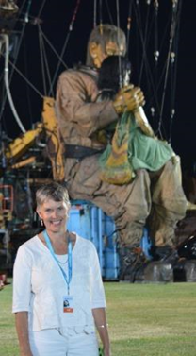
Dianne Wolfer - author
Dianne is the award-winning author of 26 books for children and teenagers, with three titles due for release in 2025: Soaring with the Sugarbird Lady – the Robin Miller story, The Colt from Old Regret, and Cattle Muster. Her latest novel Scout and the Rescue Dogs, won the 2024 WA Premier’s Award and was shortlisted for CBCA and WAYRBA. Now in US hardback, it celebrates kindness during the 2019/20 Black Summer bushfires. Other recent titles include CBCA Notable The Last Light Horse, Skye Blackburn-Lang: eating bugs for the planet (Aussie STEM Star series), and Mia, set in the Pilbara during Cyclone Veronica (Allen & Unwin’s award-winning ‘Through my Eyes’ Australian Disaster Zone series).
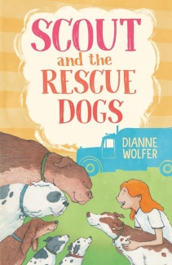
Dianne lives on the south coast of Western Australia. Her PhD research into Crafting Animal Characters in Children’s Literature (winner 2017 Board of the Graduate Research School Dean’s List) resulted in two novels, The Dog with Seven Names and The Shark Caller. The latter, a cross-cultural adventure quest, was a CBCA Notable and shortlisted for WAYRBA. The former won the 2019 Speech Pathology Awards, was shortlisted for the NSW Premier’s Awards, and is published in Chinese.
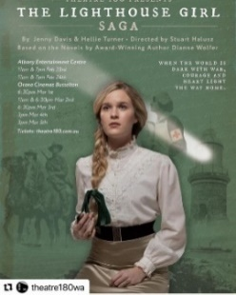
Dianne’s multi-adapted WWI ‘Light’ series is the inspiration for Theatre 180’s CineStage The Lighthouse Girl Saga, playing to audiences across Western Australia. The ‘Light’ books include, Light Horse Boy, a CBCA Honour Book and winner of the WA Premier’s Award, and Lighthouse Girl set in 1914, when the 1st AIF fleet gathered in Albany before heading to war. Lighthouse Girl won the WA Young Readers’ Book Awards, was a CBCA Notable, inspired a Black Swan adaptation and Perth Festival’s spectacular street-theatre, Little Girl Giant. In the Lamplight also a CBCA Notable, was serialised in The West Australian newspaper, while The Last Light Horse was longlisted for Book Links 2023 Award for Children’s Historical Fiction.
Other recent titles include Munjed Al Muderis: from refugee to surgical inventor, Nanna’s Button Tin, republished with Candlewick US, and CBCA shortlisted Granny Grommet & Me, celebrating Albany’s surfing grannies. An earlier picture book, Photographs in the Mud, set along the Kokoda Track, was used as an international peace reference, and is published in Japanese. YA title, Choices, also published in Polish, was commended for the Family Therapists Children’s Literature Award.
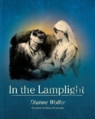
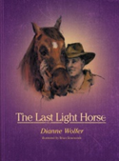
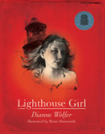
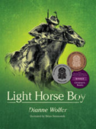
Dianne is a passionate advocate for children’s literature in Australia. She served six years as WA Advisor for the Society of Children’s Book Writers and Illustrators (2006-2012) and currently serves as PAL retreat Coordinator. In 2019 Dianne was awarded the biennial SWW Nance Donkin Award and in 2013, won the Louise Schofield Award for services to SCBWI. She is a Room to Read ambassador and sponsors literacy Story Dog, Buttercup. More information can be found at www.diannewolfer.com and www.animalswhotalk.com .

